Here are sone strong, characterful, expressive and bit cartoony pencil drawings with descriptions, that are yet not coloured in.
Old lady description
Heathers physicality and use of her body has inspired this drawing and characterisation, i want to emphasise her long lean limbs by making some parts of her costume tight and others baggy ,she should seem as if she has shrunk within her clothes. She is wiry, feisty., spirited and facially Very expressive, with a clownish or stylised quality.
This Drawing shows heather with her foot on a chair to the left and in the foreground, revealing her sexy long red football sox pulled over her knee and showing sone of her skinny thigh. She is exercising with two homemade dumbbells, and throws her head slightly back with her arms in a strongman pose.
She Wears a beige, with patch pockets loose over dress, made from a pair of mens bib and braces It has an irregular shape. A below knee A line skirt underneath this with a gird pattern on it, possibly cream base and some sort if dusky pink lines, 70' s style. See what i find. There are Pockets for glasses and rag. To contrast is A black tight fitting top with quite a low scooped neck, the tight fittingness emphasises her lean limbs.
Black top has over it Two different arms, cut off from two different jumpers, one white and other white and black stripe. The whole thing is attached together so not to fall off when moving.
The concept is that she has made and created this herself, over time and is good at sowing, make and mend. Hair sticks out and i would like to explore idea of her face and skin being pale, etiolated from no light and Emphasising the arch of her eyebrow and a touch of redness to lip. She Wears trainers with yellow laces which works well with her keep fit image.
Here below another image of old ladys costume but more schematic picture that shows costume from different angles and its irregular hem.
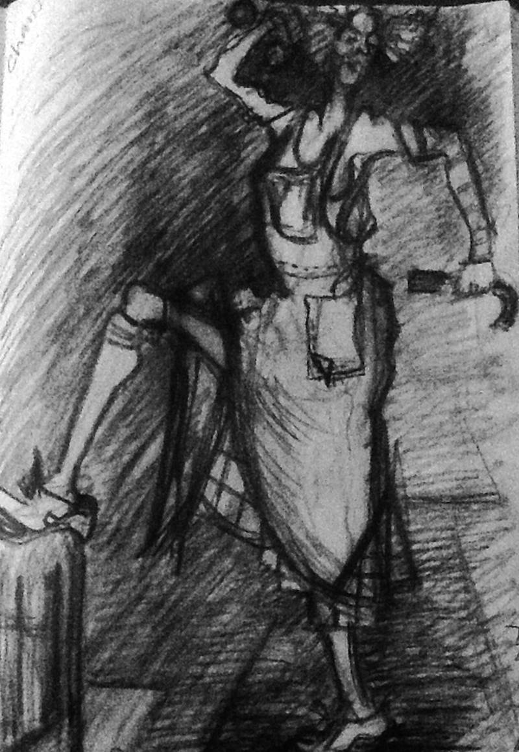
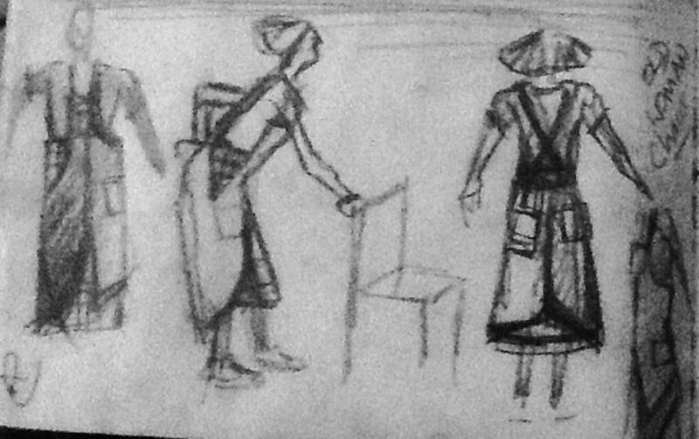
Here is old man drawing
Old man
Jons body language, his strong stance and the way he holds onto stick firmly with his bottom lip determined and pouting , shoulders hunched has inspired this picture. i have emphasised this pose and exaggerated it with the boiler suit to make his top seem tighter and body more bulky and longer, so his legs seem shorter . The trouser legs are also different lengths. He wears two different sox to echo old ladies arm design. A stripy and a plain sock. He wears simple black plimsolls, white laces possibly . White Colar, cuffs and breast pocket detail on the Janitors beige boiler suit.
Also same whitish face, as old lady, emphasise arched eyebrows and touch of colour to lips. In this picture his hair is all array , he is holding mop purposefully in his hand to left of picture, hunching his shoulders and wears costume, as described, his legs are slightly bandy.
When i drew this picture the legs became slightly bandy,i thought as an idea this could be interesting maybe to try with Aiden's help, to develop jons age and give him an even more distinctive physicality.
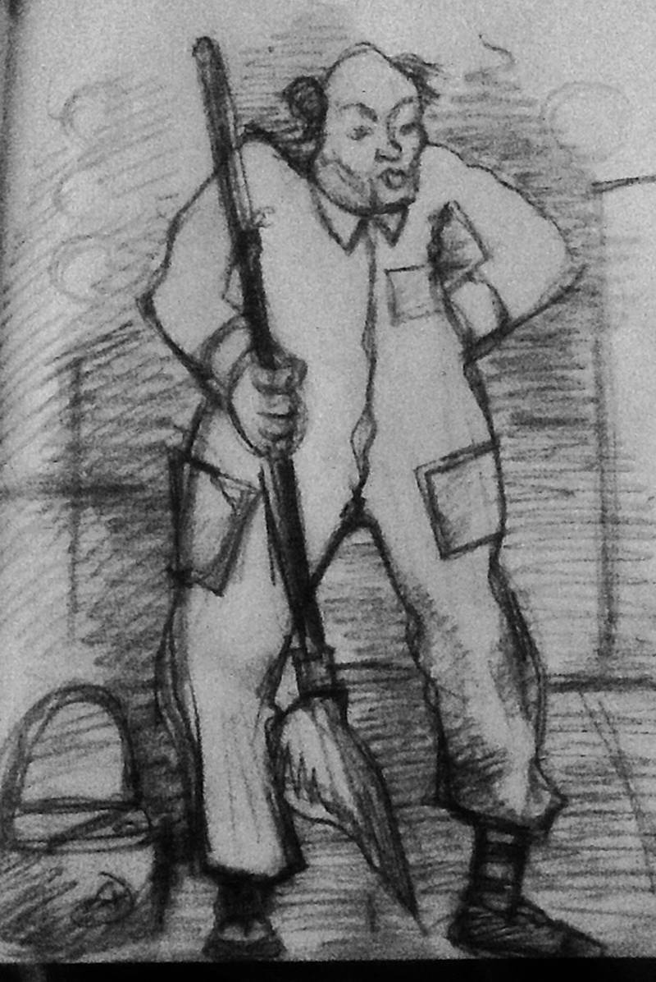
Oritor, below are two pictures that explore , two different mask ideas, one with breathing tube, one wirhout.
He wears a White paper contamintion suit, yellow, calf length wellies
Mask with round snout with or without tube coming from it.
yellow tinted lenses to goggles attached to mask like a gas mask but away from war image.
plus all the additions you have spoken of to add in....
Utility belt, equipment etc. Not yet in drawing but i will see what i find. Like the selfy idea.
